|  |
| --- |
| **C:\Users\Saleem\AppData\Local\Microsoft\Windows\INetCache\Content.MSO\38FBBA08.tmp**  **Air University**  **Mid Semester Examination Fall 2024**  Subject:- Computer Networks Lab Date: 08/11/2024 Total Marks: 70 Time: 02:30 – 04:30  Course Code: CS360L Max Time Allowed: 120 mints  Class: BSCYS FM(s) Name: Mr. Mahaz Khan  Semester: III FM Signature:  Section(s): A/B  ***Instructions:***   * Attempt all questions. * Submit packet tracer file on the GCR. The file name should be your Registration# only. * Copied paper will be getting zero marks and further action will be taken as per university policy. |

|  |  |  |  |
| --- | --- | --- | --- |
| **Question 1** | **CLO 2** |  | **Marks: 70** |

Consider the following network Topology and fulfill the following requirements.

**Network Topology:**

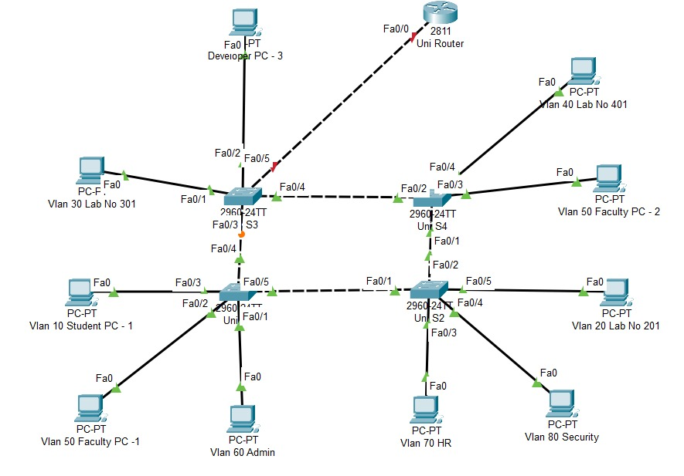

**Requirements:**

1. Design ***IP scheme*** for whole network shown in the figure. Assign the designed IP scheme to each VLAN, and Routers. Assign IP address, subnet mask and default gateway to each PC in the network. Also fill the IP Scheme table. *[9 + 6 =15 Marks]*
2. Configure the ***basic configuration*** on each switch and router. *[10 Marks]*
3. Create ***VLANs*** according to the following VLAN Table. *[5 Marks]*
4. Apply high security measures on each switch. *[10 Marks]*
5. Allow ***inter VLAN Communication*** according to the following requirements. *[5* x *3=15 Marks]*

* VLAN 10, VLAN 20, VLAN 30 and VLAN 40 can communicate each other.
* VLAN 50, VLAN 60 and VLAN 70 can communicate each other.
* VLAN 60, VLAN 70 and VLAN 80 can communicate each other.

1. The Developers PCs ( PC1 , PC2 , PC3 ) can communicate each other. *[15 Marks]*

**VLAN Table**

|  |  |  |  |
| --- | --- | --- | --- |
| VLAN | Name | Switch Name | Interface Assigned |
| 10 | Reg-Student | Uni S1 | F0/1 |
| 20 | Reg-Lab-201 | Uni S2 | F0/11 |
| 30 | Reg-Lab-301 | Uni S3 | F0/1 |
| 40 | Reg-Lab-401 | Uni S4 | F0/1 |
| 50 | Reg-Faculty [ Faculty PC-1 ] | Uni S1 | F0/3 |
| Reg-Faculty [ Faculty PC-2 ] | Uni S4 | F0/2 |
| 60 | Reg-Admin | Uni S1 | F0/4 |
| 70 | Reg-HR | Uni S2 | F0/1 |
| 80 | Reg-Security | Uni S2 | F/02 |

**Addressing Table**

| VLAN | Network IP Address | Subnet Mask | Default Gateway |
| --- | --- | --- | --- |
| VLAN 10 |  |  |  |
| VLAN 20 |  |  |  |
| VLAN 30 |  |  |  |
| VLAN 40 |  |  |  |
| VLAN 50 |  |  |  |
| VLAN 60 |  |  |  |
| VLAN 70 |  |  |  |
| VLAN 80 |  |  |  |
| Network between R1 and R2 |  |  |  |
| Network between R2 and R3 |  |  |  |
| Developer PC-1 |  |  |  |
| Developer PC-2 |  |  |  |
| Developer PC-3 |  |  |  |

***Note:*** The name of switches, routers and VLAN should start with your registration number.

124578-S1# for Switches

124578-R1# for Routers

124587-Student for VLAN 10

124587-Faculty for VLAN 20

and so on.